Supplementary Data
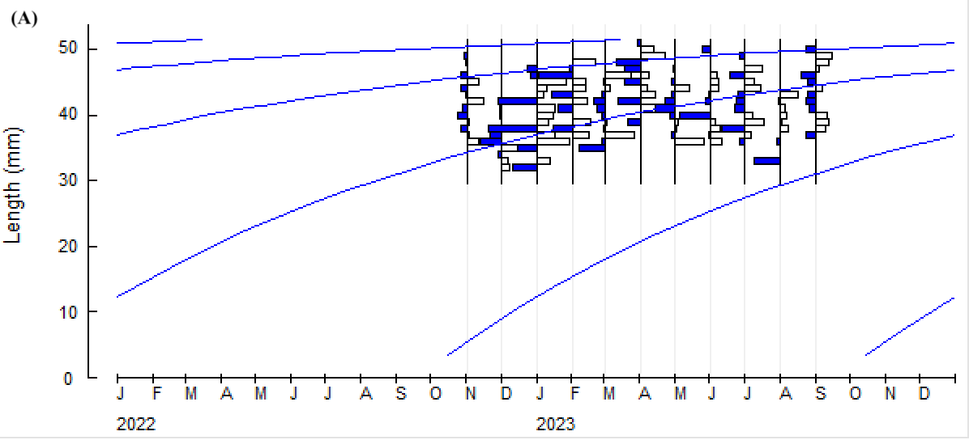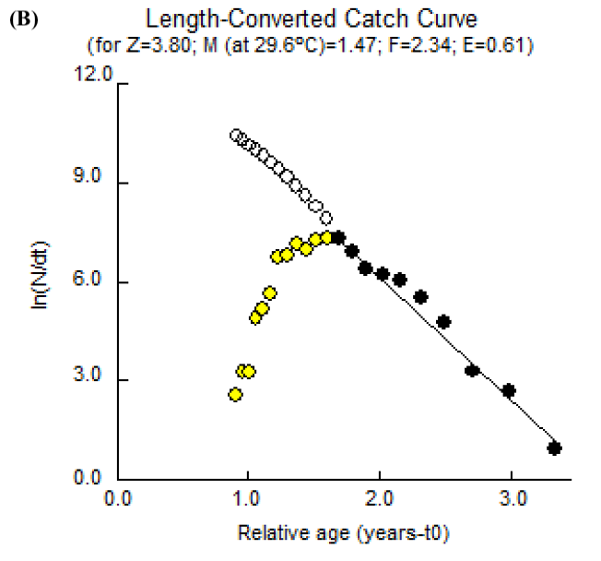
Figure S4. Restructured shell length (SL) frequency distribution and growth curves derived using the von Bertalanffy growth function (VBGF) (A), and the length-converted catch curve (B) for the short-necked clam (Paratapes undulatus) from the Ba Lua Archipelago, An Giang Province, South-western Sea of Viet Nam

