SUPPLEMENTARY MATERIAL

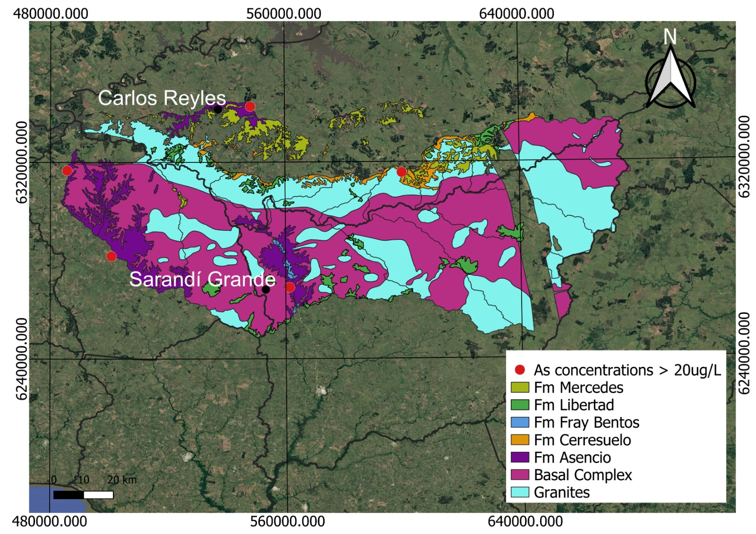
Figure 1_{SM}. Regional hydrogeological map indicating the location of public wells with As concentrations higher than 20µg/L and the municipalities of Carlos Reyles and Sarandi Grande. The occurrence of Fm Asencio in both municipalities motivated the exploratory work through the evaluation of field data and geological profiles.
Source: Public data provided by DINAGUA (“Dirección Nacional de Aguas”, Uruguayan governmental institution)
Table 1_{SM}. Descriptive statistics for the physicochemical parameters of groundwater samples collected at the municipality of Carlos Reyles (public data).
ID OSE | ID present study | n | T | pH | EC (µS/cm) | Hardness (mg/L) | Alkalinity (mg/L) | Cl (mg/L) | NO₃ (mg/L) | F (mg/L) | SO₄ (mg/L) | Na (mg/L) | As (µg/L)
Dur.CR.57.1.002 | CR3 | 5 | 6.0±2.6 | 6.6±0.0 | 589±16 | 159±3 | 197±16 | 48±4 | 13±2 | 0.00±0.00 | 17±1 | 61±3 | 10±1
Dur.CR.57.1.003 | CR4 | 7 | 7.0±0.6 | 6.8±0.1 | 727±59 | 213±1 | 277±2 | 47±1 | 24±1 | 0.00±0.00 | 17±1 | 72±5 | 14±4
Dur.CR.57.1.012 | CR5 | 3 |  | 7.0±0.1 | 1037±70 |  |  |  |  |  |  | 119±51 | 19±15
Maximum values |  |  | 8.0 | 7.1 | 1087 | 215 | 278 | 52 | 26 | 0.00 | 19 | 155 | 30
Minimum values |  |  | 3.0 | 6.6 | 575 | 157 | 178 | 45 | 12 | 0.00 | 16 | 58 | 8
Mean values ± standard deviation |  |  | 6.3±1.7 | 6.8±0.2 | 722±155 | 186±30 | 237±45 | 47±2 | 19±6 | 0.00±0.00 | 17±1 | 75±26 | 13±6
Source: Public data provided by OSE (“Obras Sanitarias del Estado”, Uruguayan governmental institution)

Table 2_{SM}. Descriptive statistics for the physicochemical parameters of groundwater samples collected at the municipality of Sarandi Grande (public data).
ID OSE | ID present study | n | T | pH | EC (µS/cm) | Hardness (mg/L) | Alkalinity (mg/L) | Cl (mg/L) | NO₃ (mg/L) | F (mg/L) | SO₄ (mg/L) | Na (mg/L) | As (mg/L)
Fl.SG.55 - PE2 | SG1 | 4 | 4.2±4.9 | 7.2±0.0 | 1520±0 | 249±0 | 566±0 | 87±0 | 35±0 | 0.77±0.00 | 95±0 | 252±1 | 13±1
Fl.SG.73.1.013 - PE7 | SG2 | 2 | 8.0±1.4 | 7.4±0.0 | 1364±0 | 161±0 | 481±0 | 65±0 | 25±0 | 1.00±0.00 | 120±0 | 259±3 | 23±4
Fl.SG.73.1.005 - PE5 | SG3 | 4 | 5.7±3.9 | 7.2±0.0 | 1218±28 | 264±0 | 470±0 | 77±0 | 35±0 | 0.59±0.00 | 37±0 | 152±15 | 9±0
Fl.SG.73.1.003 - PE4 | SG4 | 3 | 5.3±4.6 | 7.4±0.0 | 953±0 | 258±0 | 396±0 | 37±0 | 25±0 | 0.72±0.00 | 32±0 | 113±0 | 9±0
Fl.SG.307/2 - PE3 | SG5 | 3 | 5.7±4.9 | 7.2±0.0 | 1326±7 | 263±0 | 537±0 | 83±0 | 34±0 | 0.61±0.00 | 52±0 | 198±2 | 14±1
Maximum values |  |  | 9.0 | 7.4 | 1519 | 264 | 566 | 87 | 35 | 1.00 | 120 | 262 | 26
Minimum values |  |  | 0.0 | 7.2 | 953 | 161 | 396 | 37 | 25 | 0.59 | 32 | 113 | 9
Mean values ± standard deviation |  |  | 5.5±3.9 | 7.3±0.1 | 1306±184 | 239±44 | 490±66 | 77±20 | 31±5 | 0.74±0.16 | 67±38 | 204±56 | 15±6
Source: Public data provided by OSE (“Obras Sanitarias del Estado”, Uruguayan governmental institution)

Table 3_{SM}. Mann-Whitney test for stochastic equality, considering As concentrations (OSE public data) of public wells in Carlos Reyles and Sarandi Grande.
U | 39.5
Z | 0.87274
p | 0.38281

Figure 2_{SM}. Spearman correlation analysis for the physicochemical parameters of groundwater samples from Carlos Reyles, considering OSE public data.
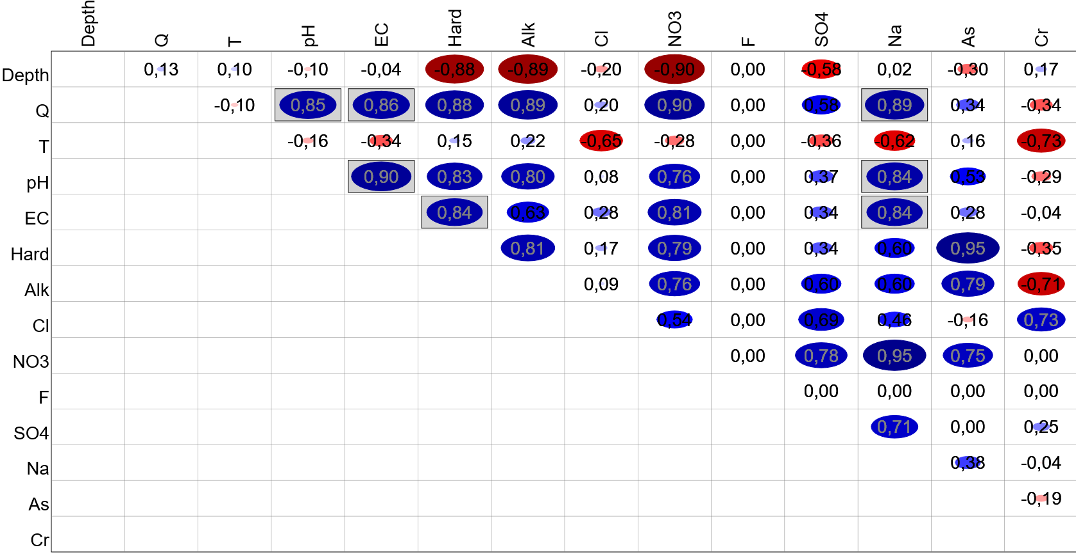
Figure 3_{SM}. Spearman correlation analysis for physicochemical parameters of groundwater samples from Sarandí Grande, considering OSE public data.
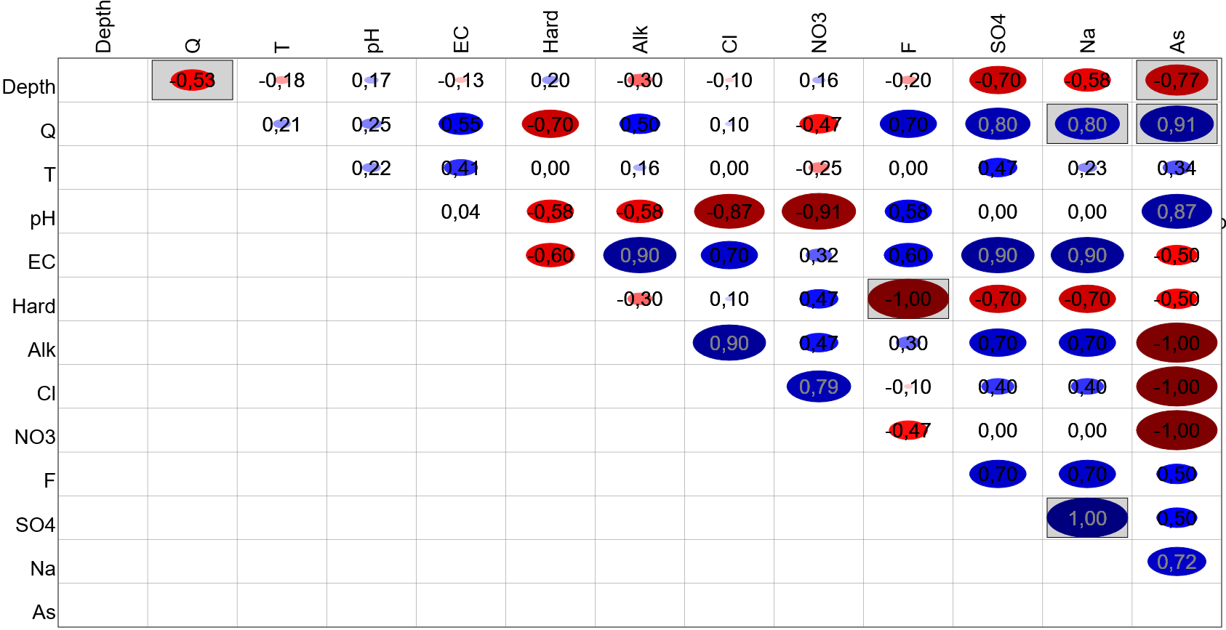
Table 4_{SM}. Results of chemical analysis for the groundwater sampled in this study (Nd = not determined)
Well ID | Na (mg/L) | Mg (mg/L) | K (mg/L) | Ca (mg/L) | Mn (µg/L) | Fe (µg/L) | Pb (µg/L) | F (mg/L) | Cl (mg/L) | SO4 (mg/L)
CR1 | 103 | 15.2 | 1.42 | 45.6 | 6.5 | 15 | 0.40 | 0.38 | 50.5 | 35.8
CR2 | 158 | 7.18 | 3.03 | 26.2 | 1.7 | 20 | 0.47 | 0.90 | 23.8 | 28.9
CR3 | 65.9 | 14.8 | 1.01 | 48.0 | 3.3 | 30 | 5.69 | 0.26 | 41.3 | 16.2
CR4 | 86.4 | 15.3 | 0.97 | 61.8 | 1.5 | 15 | 0.95 | 0.38 | 46.4 | 18.2
CR5 | 105 | 19.3 | 1.39 | 81.4 | 0.9 | 15 | 0.82 | 0.37 | 72.8 | 25.3
CR6 | 13.7 | 7.5 | 0.47 | 56.4 | 1.3 | 30 | 16.30 | 0.03 | 16.8 | 18.4
CR7 | 36.6 | 18.2 | 0.84 | 51.4 | 2.2 | 15 | 7.18 | 0.19 | 8.9 | 8.9
CR8 | 21.2 | 23.4 | 0.40 | 49.3 | 0.2 | 15 | 1.93 | 0.14 | 5.4 | 4.8
SG1 | 284 | 22.6 | 4.23 | 64.4 | 0.8 | 15 | 10.60 | 0.61 | 78.4 | 92.5
SG2 | 299 | 13.9 | 3.72 | 40.3 | 0.3 | 15 | 0.24 | 1.04 | 62 | 116.0
SG3 | Nd | Nd | Nd | Nd | Nd | Nd | Nd | 0.69 | 75.5 | 36.1
SG4 | 172 | 22.8 | 4.38 | 63.2 | 1.3 | 15 | 1.84 | 1.04 | 47.1 | 45.2
SG5 | 228 | 25.7 | 3.71 | 71.1 | 1.2 | 30 | 6.64 | 0.45 | 69.1 | 45.2
SG6 | 359 | 35.1 | 7.59 | 126 | 278 | 15 | 2.39 | 0.62 | 196 | 99.9
SG7 | 329 | 19.6 | 4.98 | 51.2 | 1.8 | 40 | 11.50 | 1.22 | 118 | 50.9
SG8 | 70.7 | 14.0 | 0.43 | 90.3 | 2.0 | 15 | 0.31 | 0.77 | 9.4 | 15.8

