Supplementary Material

Caffeine Adsorption in Fixed Bed Column Using Activated Carbon Modified with Graphene Oxide

Figures S1, S2 and S3 show the graphs with the experimental points of the breakthrough curves, containing the respective error bars in the graphs. It is worth mentioning that in some cases the error values ​​were very small, therefore it was not possible to clearly visualize the error bars in the graphs.

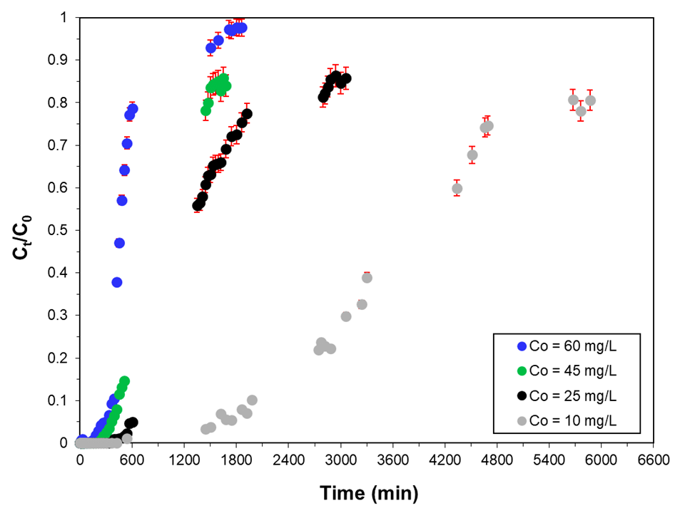
Figure S1 – Effect of different feed concentrations of caffeine solution on the breakthrough curves obtained experimentally using GO modified activated carbon with the error bars (in red) included (Experimental conditions: Q = 4 mL min⁻¹, adsorbent mass = 2 g, h = 5 cm, T = 25º C).

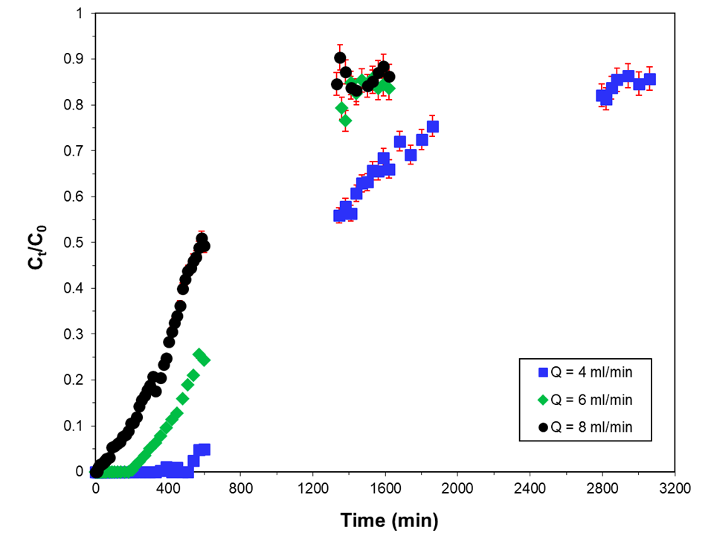
Figure S2 – Effect of the inlet flow rates on the breakthrough curves obtained experimentally using GO modified activated carbon with the error bars (in red) included (Experimental conditions: C₀ = 60 mg L⁻¹, adsorbent mass = 2 g, h = 5 cm, T = 25º C).

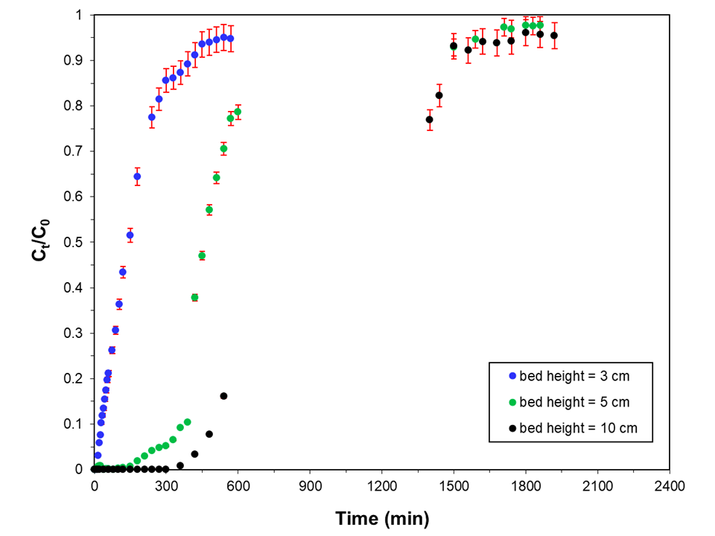
Figure S3 - Breakthrough curve obtained in the different bed sizes for caffeine removal with the error bars (in red) included (Experimental conditions: C₀ = 60 mg L⁻¹, Q = 4 mL min⁻¹, T = 25º C).

