SUPPLEMENTARY MATERIAL

Table S1 – Estimates of dissolved oxygen decay rates by aerobic sludge in the presence of the substances tested
 |  | Oxygen decay rate (mg O₂.gVS⁻¹.min⁻¹)
Substance | Doses tested (mg.L⁻¹) | control | []1 | []2 | []3 | []4 | []5
Al | 1; 3; 10; 100 | 0.056 | 0.125 | 0.056 | 0.088 | 0.52/0.09*
As | 1; 3; 10 | 0.111 | 0.146 | 0.059 | 0.057
Ba | 5; 50; 100; 1,000 | 0.188 | 0.193 | 0.203 | 0.298 | 0.52/0.39*
B | 5; 50; 100 | 2.42 | 2.548 | 0.657 | 0.518
Cd | 0.5; 5; 50 | 0.082 | 0.084 | 0.082 | 0.063
Pb | 1; 10; 50 | 0.078 | 0.074 | 0.061 | 0.056
Co | 1; 10; 50 | 1.166 | 0.324 | 0.308 | 0.403
Cu | 1; 10; 50 | 0.064 | 0.081 | 0.057 | 0.02
Hexavalent Cr | 1.5; 15; 150 | 0.548 | 0.304 | 0.107 | 0.1
Total Cr | 1; 10; 100 | 0.221 | 0.196 | 0.175 | 0.093
Sn | 1; 5; 10; 100 | 2.283 | 2.347 | 2.31 | 2.255 | 0.52/0.26*
Fe | 1; 5; 50 | 0.496 | 0.418 | 0.263 | -
Hg | 1.5; 10; 100 | 0.063 | 0.223 | 0.075 | 0.002
Ni | 1; 5; 100 | 1.683 | 1.707 | 1.749 | 0.394
Ag | 1; 5; 50 | 0.106 | 0.308 | 0.142 | 0.012
Se | 1; 5; 100 | 0.162 | 0.188 | 0.157 | 0.124
V | 4; 40; 400 | 0.09 | 0.093 | 0.063 | 0.031
Zn | 1; 5; 50 | 0.769 | 0.403 | 0.387 | 0.193
Ammonium-N | 60; 100; 500; 1,000; 1,500 | 0.26 | 0.412 | 0.822 | 0.789 | 0.14/0.14* | 0.18/0.14*
Surface-active substances | 5; 100; 1,000 | 0.376 | 0.415 | 3.531 | 0.09
Total Phenols | 5; 50; 100 | 0.209 | 0.193 | 0.142 | 0.096
Sulfide | 1; 10; 100 | 0.938 | 0.411 | 0.324 | 0.249
Cyanide | 1; 2.5; 5 | 0.041 | 0.048 | 0.054 | 0.069
Total Sulfate | 5; 100; 1,000 | 0.053 | 0.07 | 0.08 | 0.052
Total Fluoride | 10; 100; 520 | 0.024 | 0.023 | 0.025 | 0.024
The cells marked in gray indicate the concentration tested at which an inhibitory effect was observed when compared to the control
* When the substance did not present an inhibitory effect in the three doses tested, new experiments were performed at higher doses. The first number indicates the rate obtained for the fourth or fifth dose tested, while the second number (separated by the slash) indicates the control rate in the new experiments.

Table S2 – Estimates of methane production rates by anaerobic sludge in the presence of the substances tested
 |  | Methane production rate (NmL CH₄.gVS⁻¹.h⁻¹)
Substance | Doses tested (mg.L⁻¹) | control | []1 | []2 | []3
Al | 3; 100; 1,500 | 0.15 | 0.11 | 0.03 | 0.03
As | 3; 15; 150 | 0.15 | 0.07 | 0.01 | 0.00
Ba | 5; 500; 2,000 | 0.15 | 0.10 | 0.10 | 0.08
B | 5; 100; 1,000 | 0.13 | 0.13 | 0.17 | 0.03
Cd | 1; 5; 200 | 0.31 | 0.27 | 0.26 | 0.09
Pb | 0.5; 10; 100 | 0.31 | 0.29 | 0.27 | 0.31
Co | 0.5; 1; 10 | 0.16 | 0.10 | 0.16 | 0.13
Cu | 10; 50; 100 | 0.16 | 0.10 | 0.10 | 0.09
Hexavalent Cr | 0.5; 1.5; 15 | 0.08 | 0.10 | 0.11 | 0.07
Total Cr | 5; 10; 60 | 0.08 | 0.06 | 0.06 | 0.06
Sn | 0.1; 5; 10 | 0.16 | 0.11 | 0.13 | 0.13
Fe | 15; 500; 2,000 | 0.31 | 0.25 | 0.02 | 0.02
Hg | 0.5; 1.5; 10 | 0.16 | 0.03 | 0.03 | 0.03
Ni | 5; 50; 1,500 | 0.31 | 0.26 | 0.20 | 0.05
Ag | 5; 50; 100 | 0.21 | 0.15 | 0.10 | 0.10
Se | 1; 5; 10 | 0.27 | 0.28 | 0.28 | 0.28
V | 4; 40; 400 | 0.11 | 0.12 | 0.09 | 0.00
Zn | 5; 50; 100 | 0.08 | 0.11 | 0.17 | 0.07
Ammonium-N | 500; 1,500; 5,000 | 0.27 | 0.21 | 0.04 | 0.02
Surface-active substances | 5; 25; 900 | 0.11 | 0.11 | 0.09 | 0.02
Total Phenols | 5; 700; 2,000 | 0.11 | 0.09 | 0.04 | 0.02
Sulfide | 1; 5; 500 | 0.27 | 0.26 | 0.25 | 0.04
Cyanide | 1; 5; 8.5 | 0.11 | 0.11 | 0.04 | 0.04
Total Fluoride | 5; 10 e 50 | 0.16 | 0.15 | 0.13 | 0.05
Total Sulfate | 500; 1,000; 5,000 | 0.27 | 0.14 | 0.12 | 0.03
Cells marked in gray indicate the concentration tested at which an inhibitory effect was observed when compared to the control.

Table S3 - Estimates of growth rates of Chlorella vulgaris in the presence of the substances tested
 |  | Algal growth rate (mg.L⁻¹.h⁻¹)
Substance | Doses tested (mg.L⁻¹) | control | []1 | []2 | []3
Al | 1.5; 3; 6 | 1.15 | 0.65 | 0.50 | 0.66
As | 1.5; 3; 7 | 0.39 | 0.12 | 0.12 | 0.28
Ba | 1; 5; 7 | 1.39 | 1.50 | 1.49 | 062
B | 2; 5; 50 | 0.05 | -0.06** | 0.07 | -0.03
Cd | 2.5; 5; 7.5 | 0.32 | 0.09 | 0.12 | 0.05
Pb | 0.25; 1; 10 | 0.32 | 0.46 | 0.63 | 0.59
Co | 0.5; 1; 2 | 0.39 | 0.31 | 0.09 | -0.08
Cu | 5; 10; 15 | 1.39 | 0.08 | 0.24 | 0.08
Hexavalent Cr | 1.5; 30; 75 | 0.99 | 0.21 | 0.01 | -0.07
Total Cr | 1; 10; 100 | 0.99 | 0.48 | -0.07 | 0.54
Sn | 1; 5; 10 | 0.99 | 0.61 | 0.28 | 0.57
Fe | 5; 15; 50 | 1.15 | 1.19 | 0.72 | 0.87
Hg | 0.5; 1.5; 3 | 0.39 | 0.98 | -0.003 | -0.30
Ni | 0.5; 5; 50 | 0.99 | 0.55 | 0.24 | 0.01
Ag | 2.5; 5; 7.5 | 1.39 | -0.12 | -0.03 | 0.00
Se | 5; 25; 50 | 0.01 | 0.08 | 0.02 | -0.01
V | 0.2; 2; 4 | 0.01 | -0.06 | -0.06 | -0.07
Zn | 2.5; 5; 10 | 0.39 | 0.02 | -0.02 | 0.26
Ammonium-N | 200; 500; 670 | 0.09 | 0.14 | -0.01 | 0.02
Surface-active substances | 1; 5; 10 | 0.32 | 0.49 | 0.37 | 0.42
Total Phenols | 2; 5; 50 | 0.05 | -0.02 | -0.01 | 0.04
Cyanide | 0.5; 2.5; 5 | 0.32 | 0.51 | 0.36 | 0.26
Sulfide | 0.5; 1; 5 | 0.99 | 0.49 | 0.51 | 0.52
Total Sulfate | 1; 10; 1,000 | 0.99 | 0.41 | 0.50 | 0.44
Total Fluoride | 10; 100; 200 | 0.01 | 0.05 | -0.03 | -0.01
The cells marked in gray indicate the concentration tested at which an inhibitory effect was observed when compared to the control
** Negative rates are observed when there is a reduction in the concentration of microalgae, about the previous day, that is, there was cell death

Fig. S1 – Example of representation of the dissolved oxygen decay rate for tests with aerobic biomass in the presence of Mercury
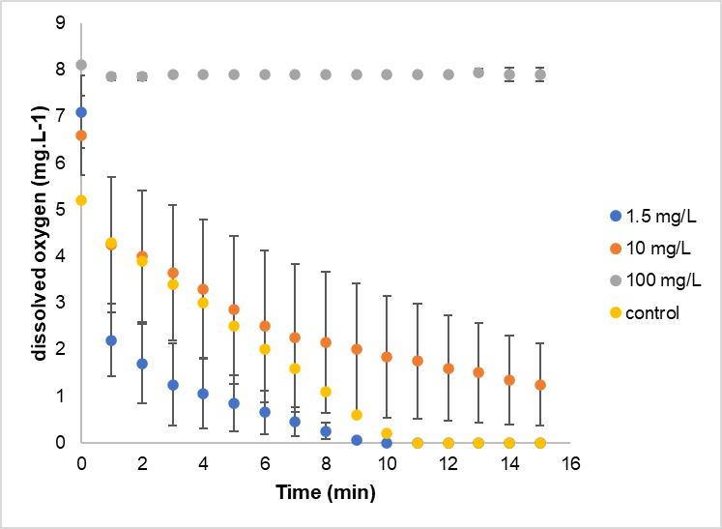

Fig. S2 – Example of the graph of accumulated methane production for tests with anaerobic biomass in the presence of Arsenic
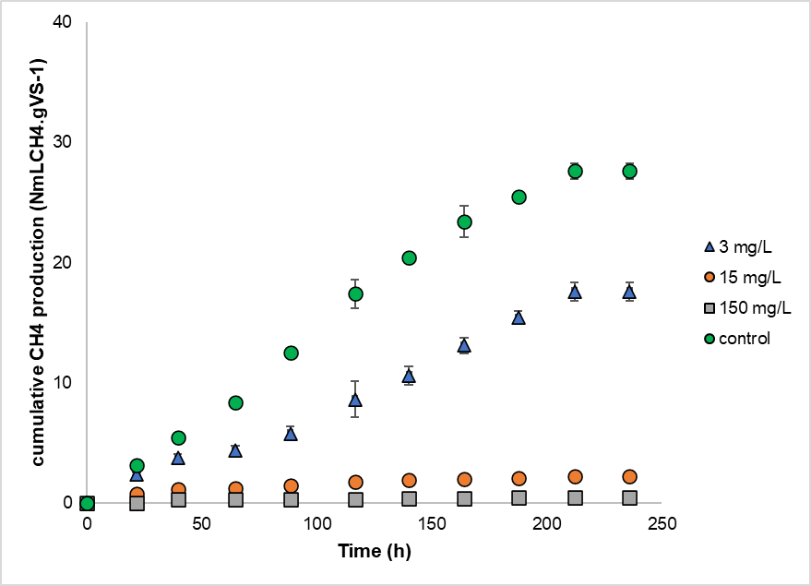

Fig. S3 – Example of representation of algal biomass density performed with Chlorella vulgaris in the presence of Copper
