SUPPLEMENTARY MATERIAL 2 – FIGURES AND TABLES
Title: Screw versus Suture in the Fixation of Tibial Spine Fractures: A Systematic Review, Meta-Analysis, and Meta-Regression.

PROSPERO ID: CRD420251022233.

Figure S1. Leave-one-out sensitivity analysis for the functional outcome (IKDC).
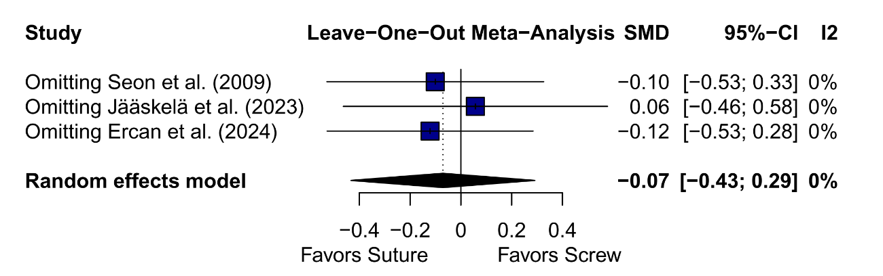
Figure S2. Sensitivity analysis of the Lysholm score as reported by Ercan et al. (2024).
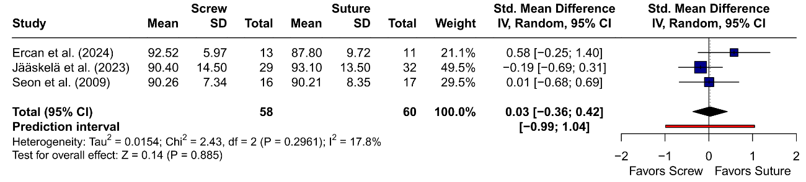
Figure S3. Contour-enhanced funnel plot for the primary functional outcome.
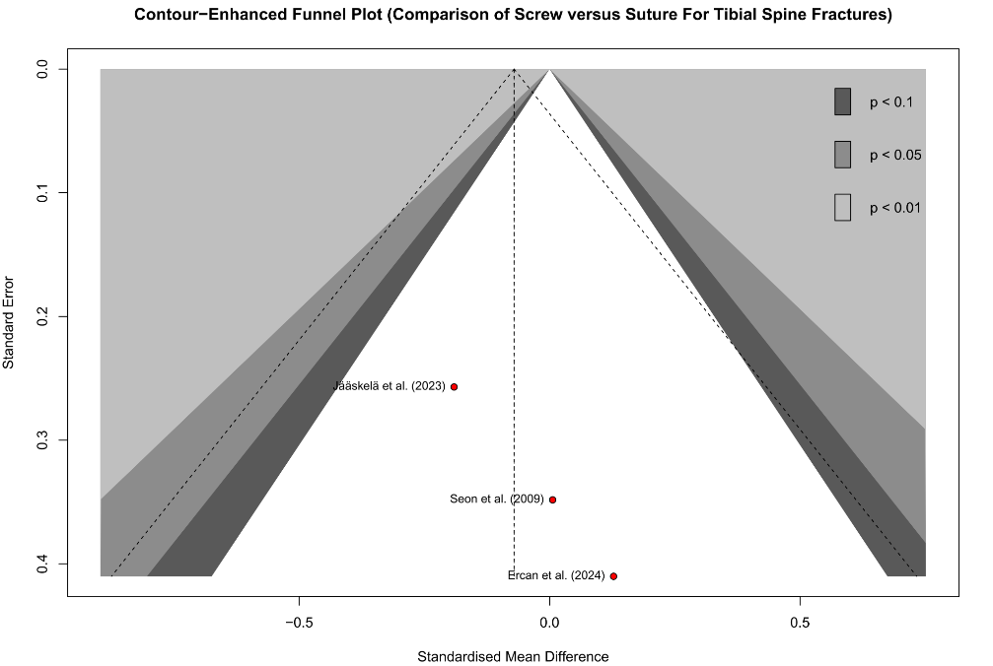

Figure S4. Bubble plot (scatter plot) of meta-regression between the mean age of participants and the functional outcome measured by the IKDC score.
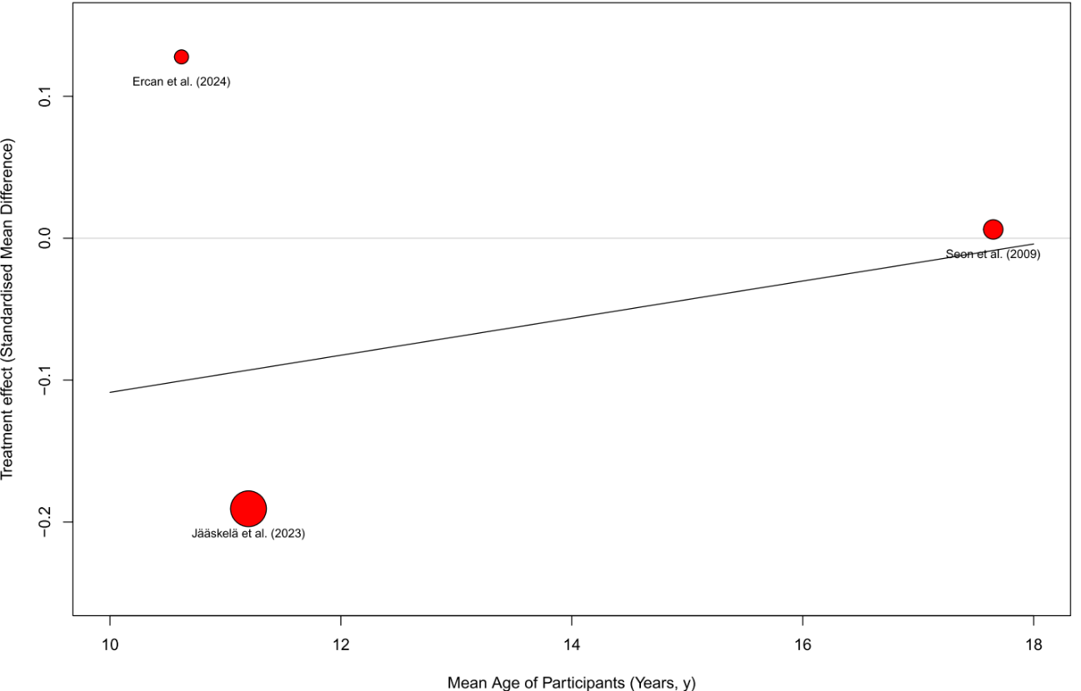
Figure S5. Bubble plot (scatter plot) of meta-regression between mean fracture severity (Meyers–McKeever classification) and the functional outcome measured by the IKDC score.
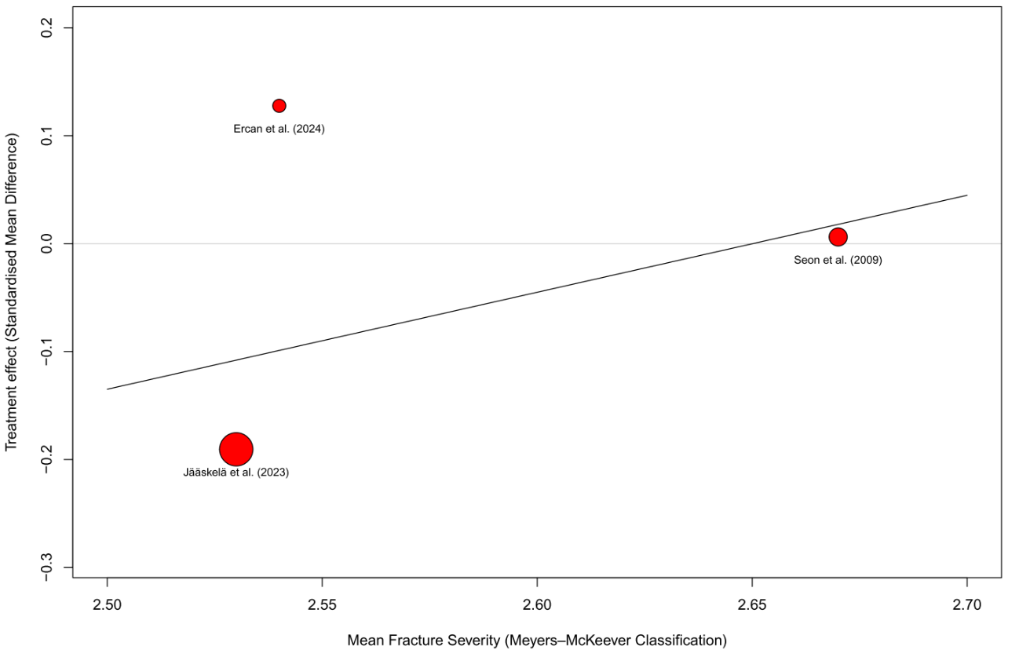
Figure S6. Bubble plot (scatter plot) of meta-regression between the mean proportion of patients treated arthroscopically and the functional outcome measured by the IKDC score.
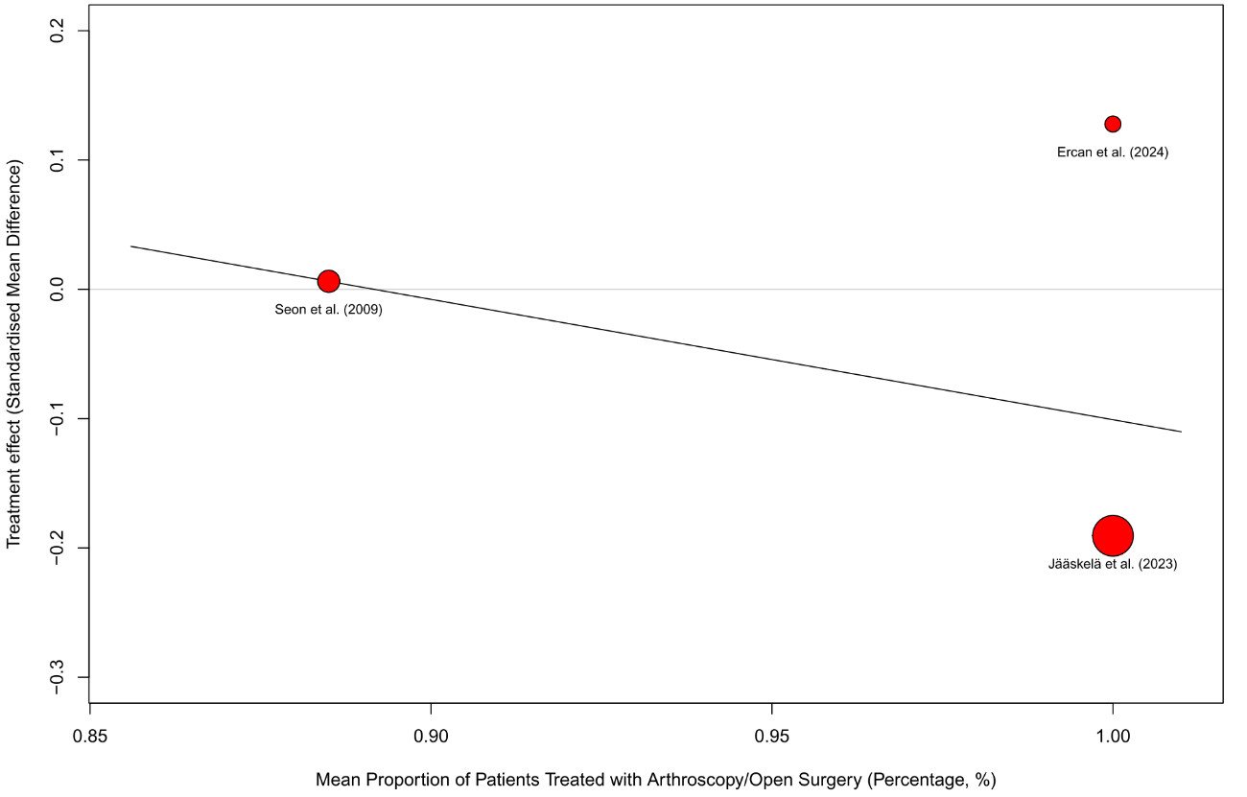
Figure S7. Bubble plot (scatter plot) of meta-regression between the mean proportion of male patients and the functional outcome measured by the IKDC score.
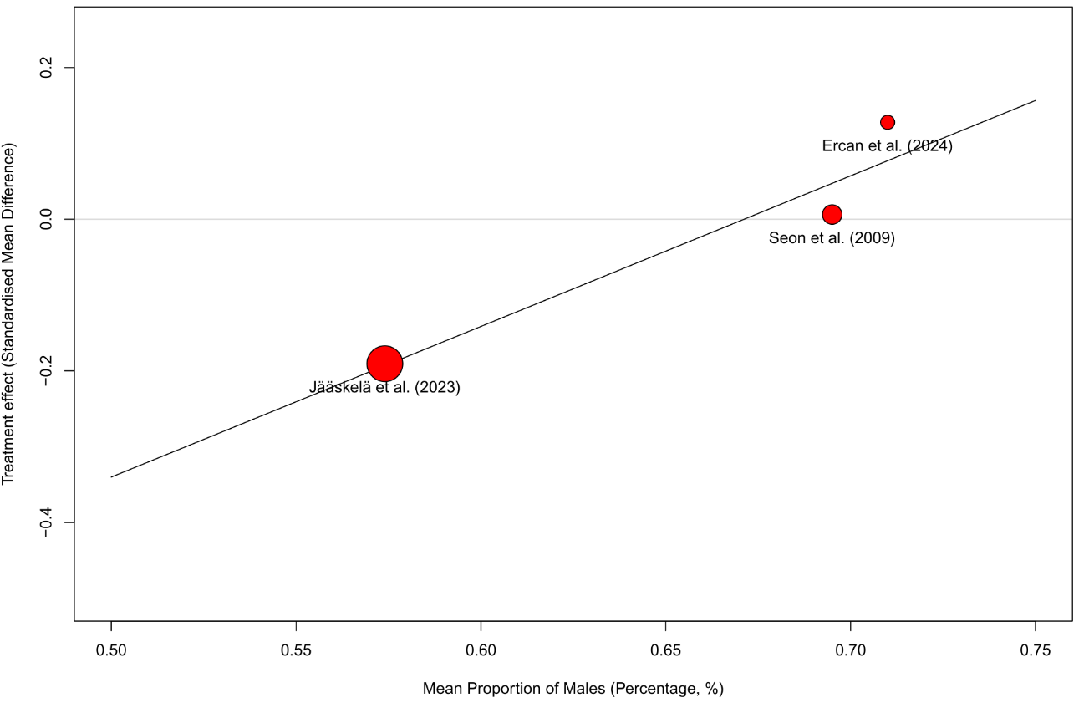
Figure S8. Forest plot of the meta-analysis comparing operative time (in minutes).
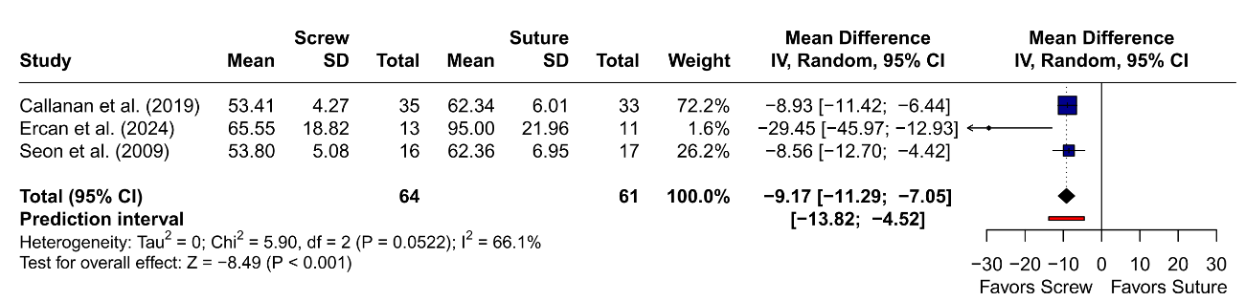
Figure S9. Leave-one-out sensitivity analysis for operative time.
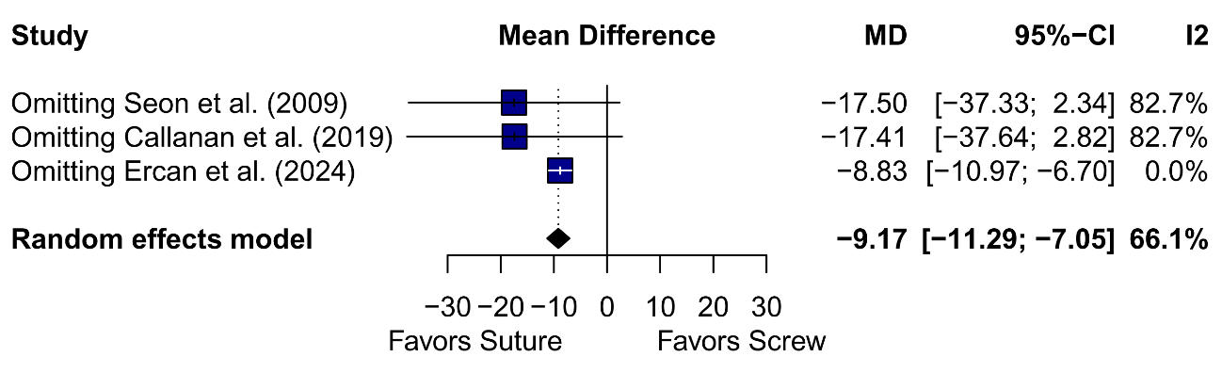
Figure S10. Forest plot of the relative risk of knee instability (Lachman test).
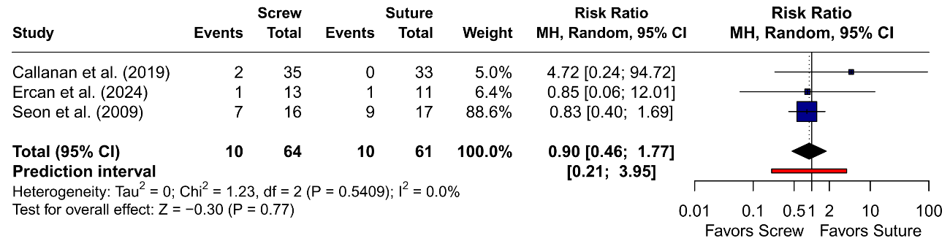
Figure S11. Leave-one-out sensitivity analysis for knee instability (Lachman test).
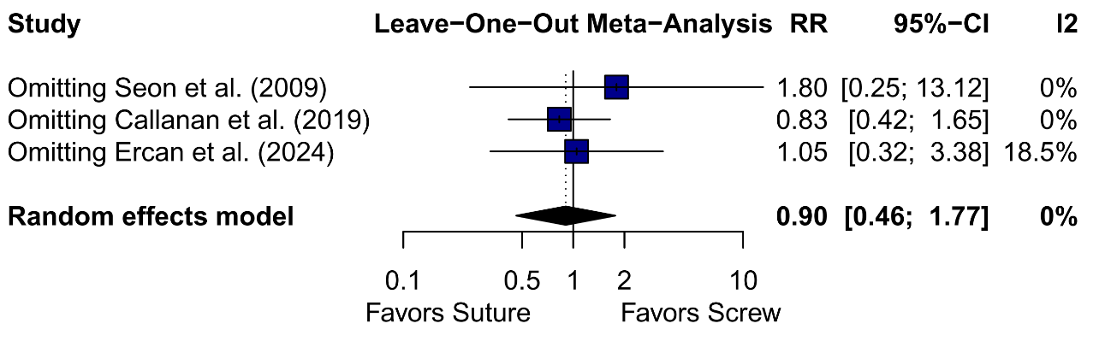
Figure S12 Forest plot comparing the risk of failure to return to sport.
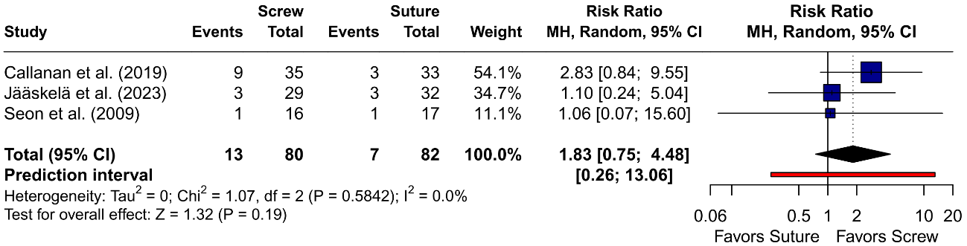

Figure S13. Leave-one-out sensitivity analysis for failure to return to sport.
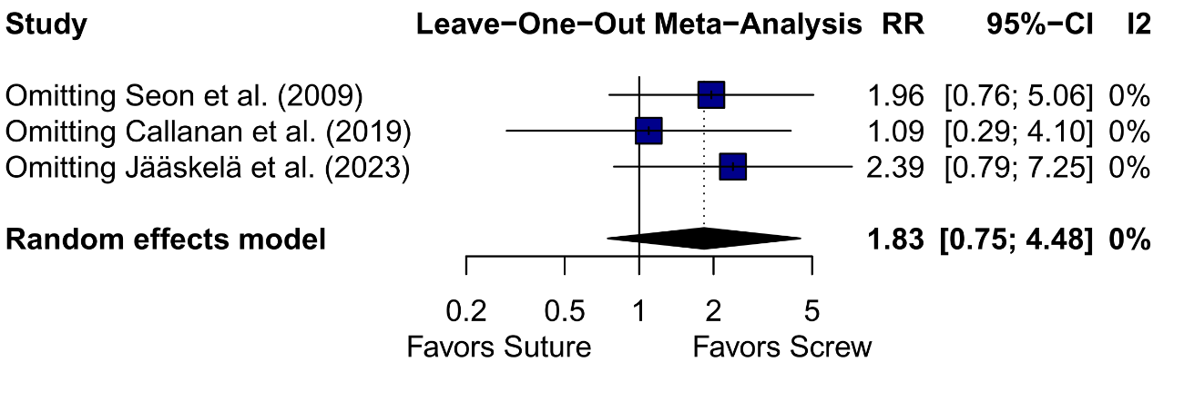
Figure S14. Forest plot of the relative risk of reoperations.
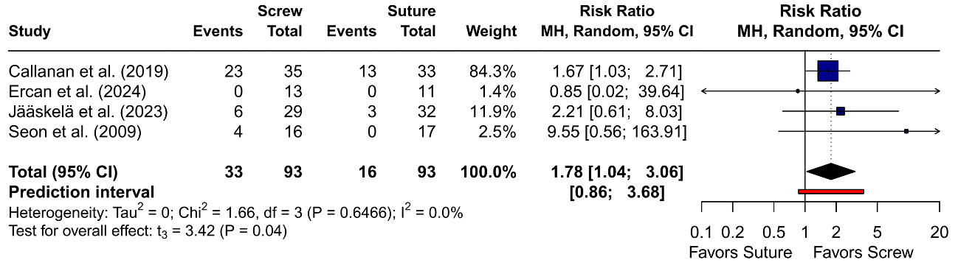

Figure S15. Leave-one-out sensitivity analysis for reoperations.
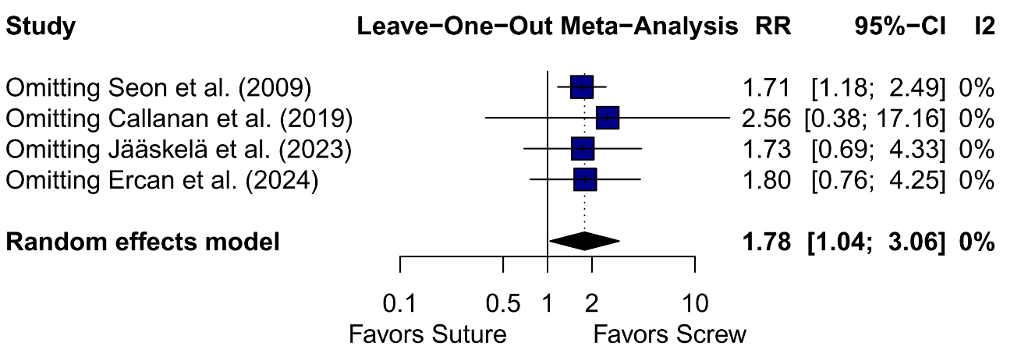
Figure S16. Forest plot comparing the relative risk of implant removal.
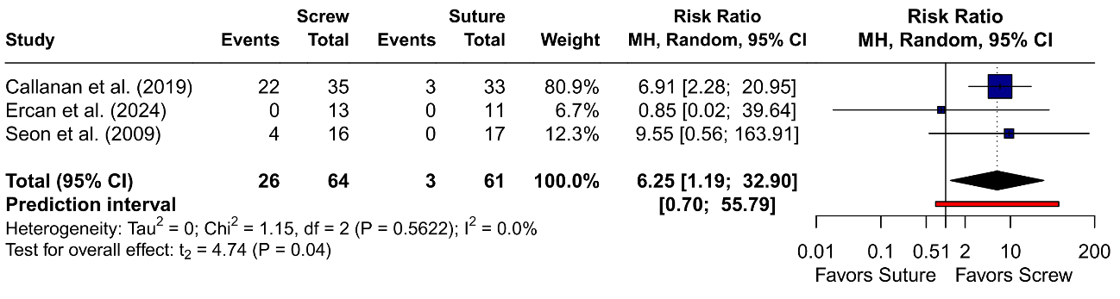
Figure S17. Leave-one-out sensitivity analysis for implant removal.
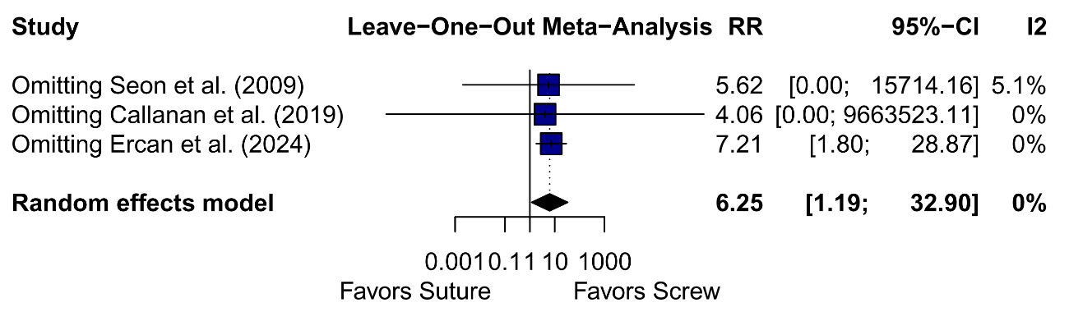

Table S1. Meta-regression between the mean age of participants and the functional outcome measured by the IKDC score.
 | Effect estimates | p-value | I² (%) | Test of residual heterogeneity
Mean age (Function)
Intercept | -0.23 | 0.77 | 0% | p = 0.83
Mean age | 0.013 | 0.83 | 0% | p = 0.83

Table S2. Meta-regression between mean fracture severity (Meyers–McKeever classification) and the functional outcome measured by the IKDC score.
 | Effect estimates | p-value | I² (%) | Test of residual heterogeneity
Mean age (Function)
Intercept | -0.23 | 0.75 | 0% | P = 0.52
Mean Fracture  Severity | 0.89 | 0.30 | 0% | P = 0.52

Table S3. Meta-regression between the mean proportion of patients treated arthroscopically and the functional outcome measured by the IKDC score.
 | Effect estimates | p-value | I² (%) | Test of residual heterogeneity
Mean age (Function)
Intercept | 0.83 | 0.81 | 0% | p = 0.51
Mean age | -0.93 | 0.79 | 0% | p = 0.51

Table S4. Meta-regression between the mean proportion of male patients and the functional outcome measured by the IKDC score.
 | Effect estimates | p-value | I² (%) | Test of residual heterogeneity
Mean age (Function)
Intercept | -1.33 | 0.47 | 0% | p = 0.86
Proportion of male | 1.98 | 0.49 | 0% | p = 0.86

