SUPPLEMENTARY MATERIAL

1. Supplementary Table S1. Details of the search strategy according to the database.

Database | Search strategy
PubMed | ("antiplatelet therapy" OR DAPT OR "dual antiplatelet" OR clopidogrel OR ticagrelor OR dipyridamole) AND aspirin AND ("ischemic stroke" OR stroke OR "brain infarct" OR "cerebral infarction") AND (mild OR moderate OR nonminor OR "non-minor")
Embase | ("antiplatelet therapy" OR DAPT OR "dual antiplatelet" OR clopidogrel OR ticagrelor OR dipyridamole) AND aspirin AND ("ischemic stroke" OR stroke OR "brain infarct" OR "cerebral infarction") AND (mild OR moderate OR nonminor OR "non-minor")
Cochrane | ("antiplatelet therapy" OR DAPT OR "dual antiplatelet" OR clopidogrel OR ticagrelor OR dipyridamole) AND aspirin AND ("ischemic stroke" OR stroke OR "brain infarct" OR "cerebral infarction") AND (mild OR moderate OR nonminor OR "non-minor")

2. Supplementary Figure S1. Risk Of Bias In Non-Randomized Studies - of Interventions (ROBINS-I).

A. Traffic light plot.

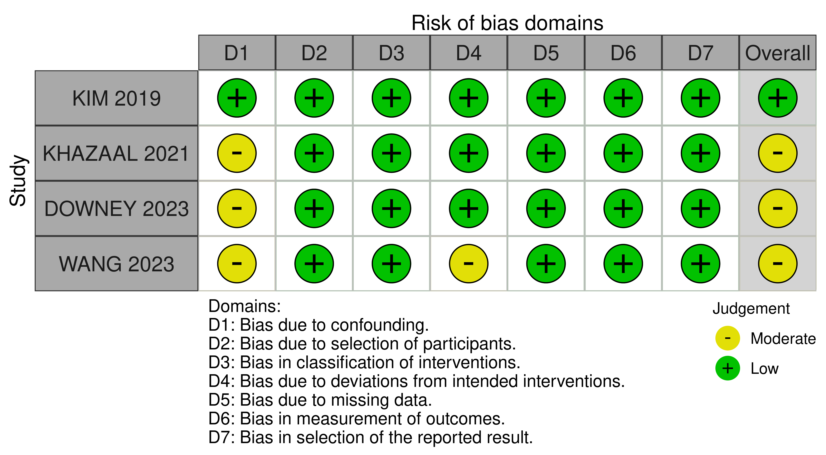
B. Summary plot.

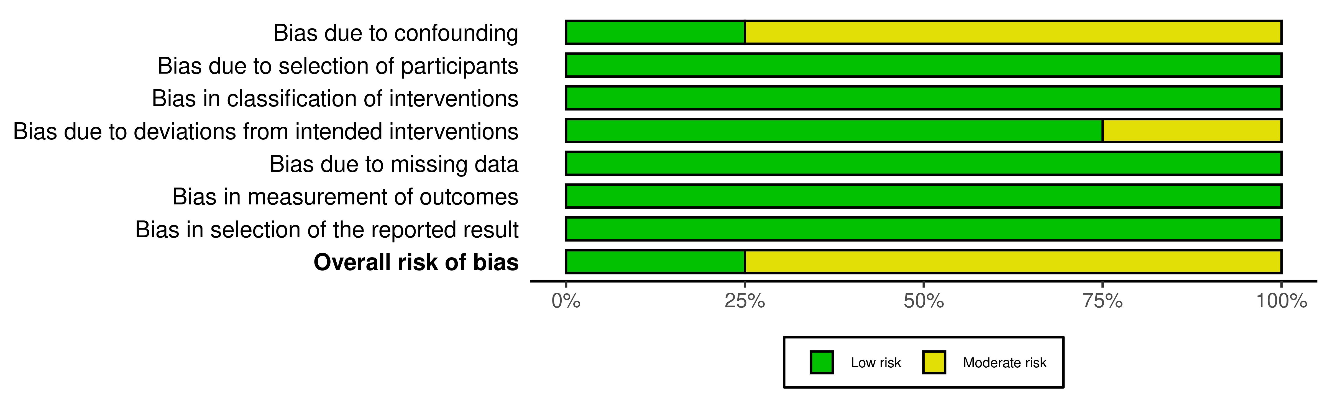
3. Supplementary Figure S2. Cochrane tool for assessing the risk of bias in randomized clinical trials (RoB 2).

A. Traffic light plot.

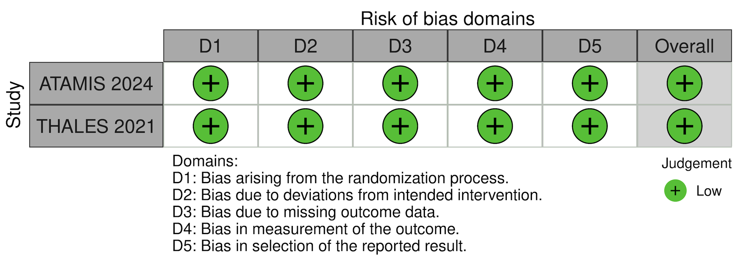

B. Summary plot.

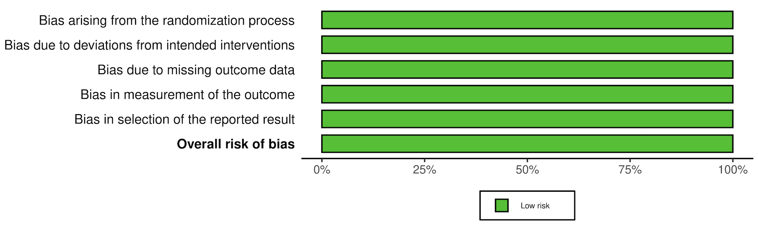

4. Supplementary Figure S3. Subanalysis in selected population.
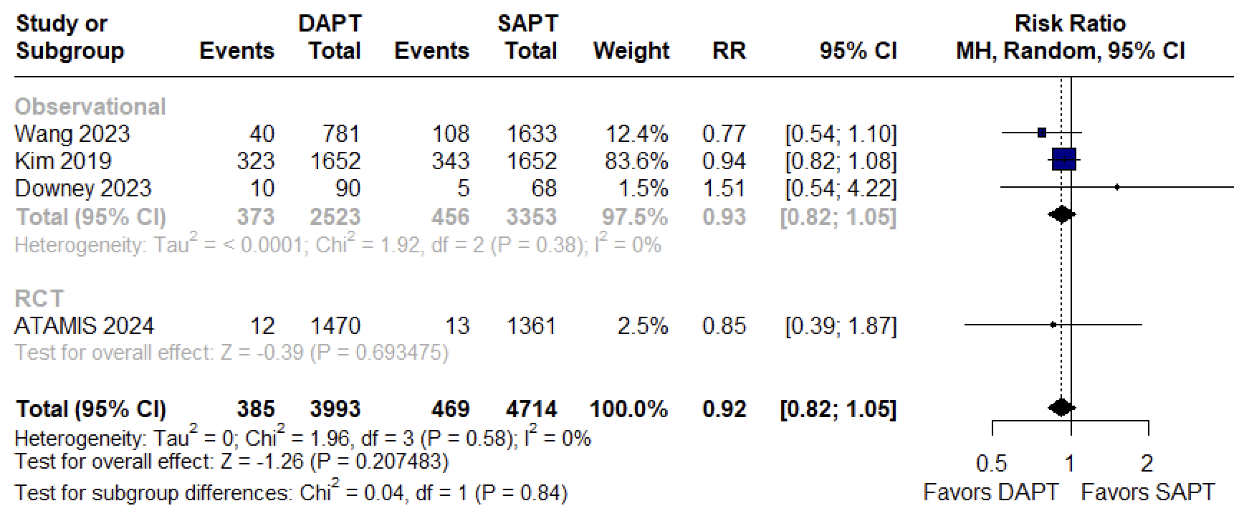
A. Recurrent stroke (excluding THALES)

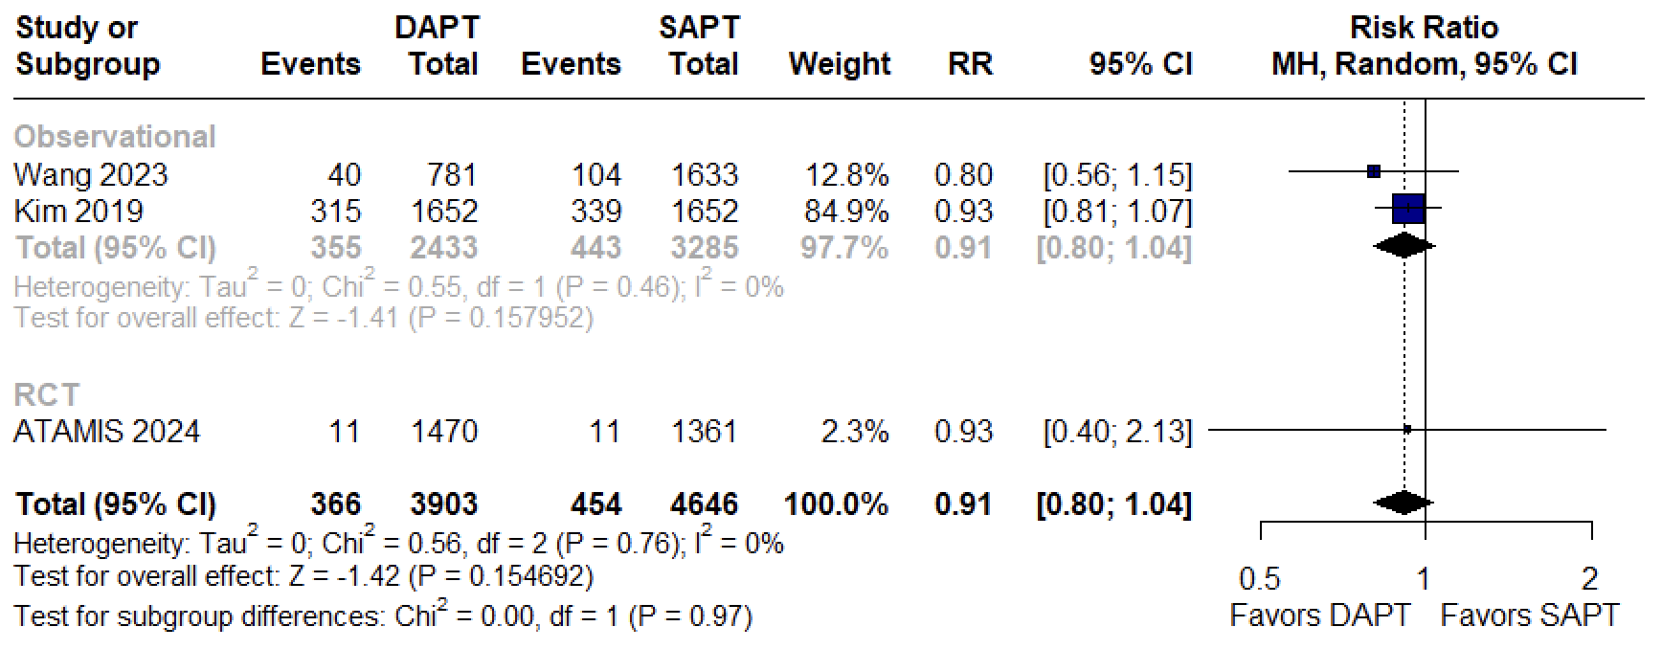
B. Ischemic stroke (excluding THALES)

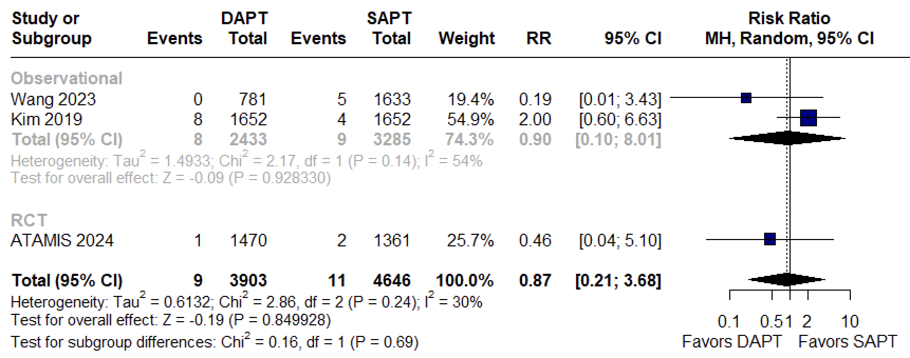
C. Hemorrhagic stroke (excluding THALES)

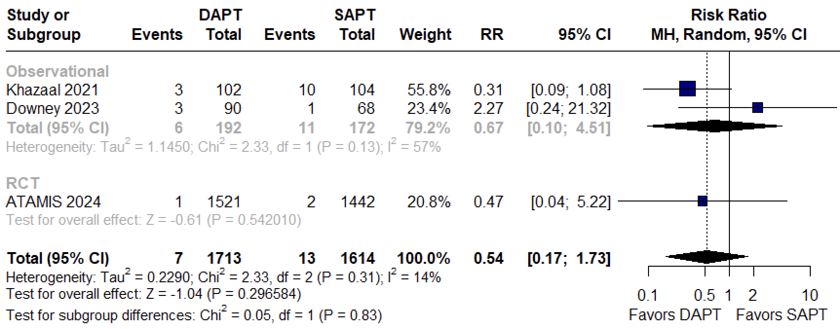
D. Major bleeding (excluding THALES)

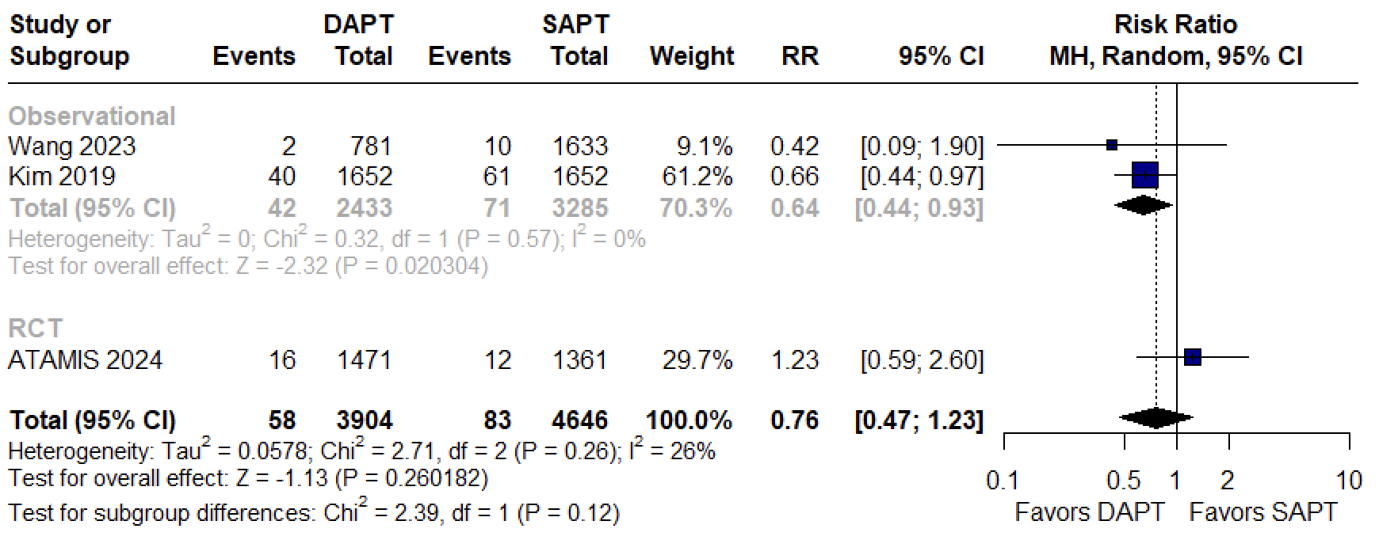
E. All-cause mortality (excluding THALES)

